Student number: ra22895

An analysis of citizens’ issues and views on the Welsh public transport system

Data Analytics Implementation

Module: The Data Professional

Contents

Introduction 1

Data analysis steps 1

Data pre-processing 1

Data visualisation 2

Data presentation and interpretation 2

Recommendations 10

Limitations 10

Further work 11

References 11

# Introduction

This report will use data from the National Survey for Wales, 2013-14 – Transport to identify key trends in overall satisfaction with transport. Overall satisfaction will be compared across different demographics and a closer look will be taken at vulnerable members of the population such as pensioners, the unemployed, and those with long term illnesses.

It is assumed that the report will be seen by a wide range of stakeholders with variable statistical skills, so the focus is on high-level data that is easy to access and interpret.

# Data analysis steps

In order to create this report the data was first considered to establish what insights might be possible. This was followed by choosing the specific tables that contained relevant data. The data was converted into a form that could be used to create charts and then compared to identify trends. The trends are explained using appropriate evidence.

Although the original proposal aimed to create an interactive dashboard using MS PowerBI the data is now presented as static charts. This is to ensure the assessment learning outcomes are met.

# Data pre-processing

Very little data pre-processing was possible as there was no raw data available for use, however the following steps were taken:

Overall satisfaction data

* Overall satisfaction by local authority (Table 5). Colours were assigned to values (darker colour is lower satisfaction) and the score for each local authority was added to a map of Wales to show geographical variation.
* Data for urban/rural (Table 4) and household type (Table 1) were plotted as bar charts.

Vulnerable group data

* For overall satisfaction by age (Table 10) only the data for the age groups 65-74 and 75+ were used. This was plotted as a bar chart.
* For overall satisfaction by limiting long-term illness (Table 12) and Employment status (Table 11) all data points were used. These were also plotted as bar charts.
* Data about ease of getting to and from a GP surgery and a hospital were concatenated for each vulnerable group (Tables 30 & 38, Tables 25 & 33, Tables 29 & 37). These were plotted as stacked bar charts. In order to plot these charts the data was first converted to a Pandas DataFrame
* Data concerning use of cars (Tables 21 & 22) and Feeling of safety (Table 40) were plotted as pie charts

# Data visualisation

The chart types were chosen to make comparison between data sets easy to see (Metwalli, 2020). Overall satisfaction was plotted as bar charts as it is comparing values across subgroups.

Stacked bar charts were used for access to services in order to best show comparisons between categories across multiple datasets.

Pie charts were used for comparisons where there were only two datasets and a small number of categories.

All charts were plotted using Matplotlib in Python, with concatenated tables converted to pandas DataFrames.

A consistent colour scheme was chosen that highlighted the difference between each category but was also easy to identify if there were any stakeholders with accessibility needs.

# Data presentation and interpretation

Opinions and attitudes towards transport vary widely across Wales, although some trends can be identified. Half of the population of Wales is concentrated in the South East, with Cardiff being the main urban centre of Wales. Because of this, there is good access to services and public transport is plentiful. There are also strong transport links East to West across North Wales, providing access to ferry routes and leisure facilities along the coast. This is reflected by the overall satisfaction in the state of the transport system when broken down by local authority (Figure 1.). The South East and the areas running across North Wales have higher overall satisfaction ratings, with scores typically being 6 or above. The exception in North Wales is Anglesey, possibly due to it being an island with only 2 bridges providing access to the mainland. The island itself is hilly with narrow and twisting roads away from main routes.

Central and Western Wales are predominantly rural areas with small populations. This means that public transport in areas off main routes may not be economically viable for local authorities, leaving rural populations potentially isolated from key services. The dissatisfaction felt in rural areas can be seen in Figure 2. which compares the overall satisfaction between urban and rural areas. Although the rural areas have much lower overall satisfaction (5.5 compared to 6.0) the average value is 5.9. This is because the urban population is much larger so the mean value will be skewed in their favour.

Figure 1. Overall satisfaction with state of transport system in Wales by local authority.

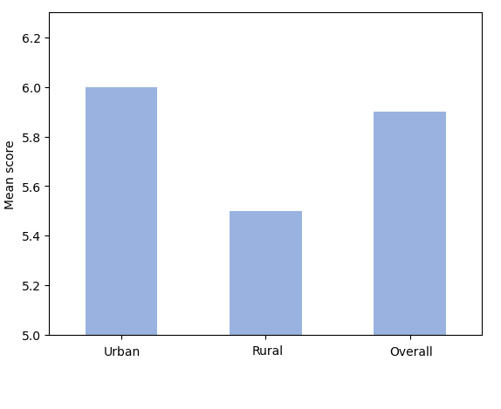

Figure 2. Overall satisfaction with state of transport system in Wales by urban/rural area

Vulnerable members of the community are particularly affected by transport issues for several reasons. In order to better understand their opinions and circumstances, additional data was reviewed.

In an increasingly aging population the percentage of pensioners has increased from 18.4% in 2011 to 21.3% in 2021 (Office for National Statistics, 2021). Key indicators for this group are access to services such as GP surgeries and hospitals. If they are relying on public transport, then feeling safe using it will also be important to them.

When looking at household type single pensioners have the highest overall satisfaction (Figure 3.) despite older age groups finding accessing a GP surgery or hospital the most difficult. One reason for the high overall satisfaction may be that pensioners receive free travel on buses and many trains in Wales. When looking at specific age groups for older people the section of the population that is 75 or older is much more satisfied with the transport system (Figure 4.) This may be because the current retirement age in the UK is 67 and many people choose to continue to work beyond that age. In 2020 approximately 12% of people over 65 were still in work. (Office for National Statistics, 2022). People who are still working, especially outside the home, have different requirements from a transport system than those who are not in work. They are more likely to be travelling at busy times so using transport when there is more pressure on the system, this could lead to lower rates of overall satisfaction.

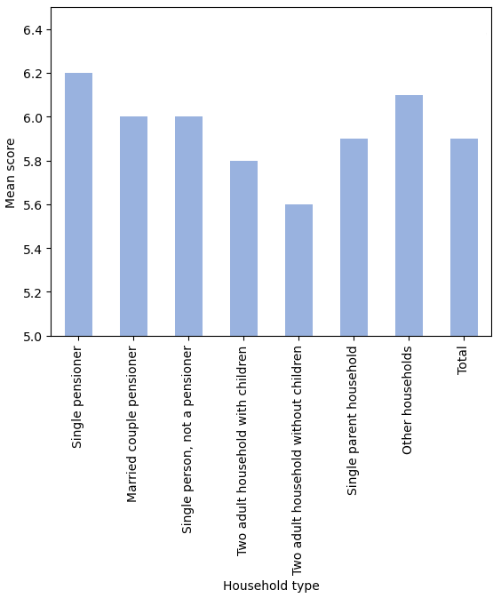

Figure 3. Overall satisfaction with state of transport system in Wales by household type

Figure 4. Overall satisfaction with state of transport system in Wales by specific age groups

The data in Figure 5 shows that as people age, they find it increasingly more difficult to access key services such as a GP surgery or hospital, with only a third of over 75-year-olds saying they found it very easy to get to and from a hospital. According to the Equality and Human Rights Commission (2020) the move to online information means older people are more likely to struggle to access things like timetables due to lack of internet access or technical skills.

As this group are more likely to have health issues (Office for National Statistics, 2021), it is difficult to state with any confidence the exact reasons for the difficulties in accessing these services without knowing the specific question(s) that were asked. For example, appointment times, mobility issues and weather conditions may all contribute. It is likely that a combination of these factors are contributing.

Safety was also considered as a factor, as 35% of passengers over 75 felt either fairly unsafe or very unsafe travelling by public transport (Figure 6.)

Figure 5. Ease of getting to and from GP surgery or hospital by age group

Figure 6. Feeling of safety travelling by public transport after dark by age group

Overall, this age group is giving mixed messages about the Welsh transport system as they have the highest overall satisfaction but the most difficult time using the system to access services. The data set cannot currently be used to identify any further factors that affect these scores.

Another vulnerable group in the community are those with limiting long-term illnesses (LLTIs), a term which covers a wide range of conditions that can be sensory, mental or physical. People with an LLTI have lower overall satisfaction with the transport system than those who do not (Figure 7.)

Figure 7. Overall satisfaction with state of transport system in Wales by limiting long-term illness

These members of the community are less likely to have use of a car (Figure 8.) so depend more heavily on public transport which has seen large cost increases in recent years (Sustrans, 2022). It may be possible to assume that people with an LLTI are spread fairly evenly through the population so there may be a very large difference in the experiences of those in rural areas compared to urban.

Figure 8. Use of a car by limiting long-term illness

Figure 9 shows that almost twice as many people with an LLTI find it difficult to access a hospital compared to those who do not have an LLTI (25% compared to 13%). The difference is even larger for accessing a GP surgery with 14% of those with an LLTI reporting that access was fairly or very difficult compared to just 4% of those without an LLTI.

The existing data does not allow for more detailed analysis, but this group are likely to face many of the same challenges as the 75+ respondents previously mentioned. It may be that some people fall into both categories so care should be taken to ensure that conclusions are not skewed by people who are being reported in multiple categories.

Figure 9. Ease of getting to and from GP surgery or hospital by limiting long-term illness

The final group to be considered are those not in employment. It is not clear from the data whether the category ‘Not in employment’ refers to just those of working age who are not currently employed or whether it includes anyone who is not in employment (students, pensioners etc.). Again, care must be taken that any conclusions drawn consider the possibility that people are being represented in multiple categories.

People not in employment have a higher overall satisfaction with the transport system than those in employment (Figure 10.) although 34% of people not in employment do not have use of a car (Figure 11.).

Figure 10. Overall satisfaction with state of transport system in Wales by employment status

Figure 11. Use of a car by employment status

The ease of travel to and from a GP surgery or hospital follows the same trend as the 75+ age group and those with an LLTI. People who are not in employment report greater difficulty in accessing services than this in employment. It is expected that this is for many of the same reasons.

Figure 12. Ease of getting to and from GP surgery or hospital by employment status

# Recommendations

The data shows that people who are older, have long-term illnesses or who are not in employment face greater challenges around transport than others in the community. Ways to tackle this could be:

* Focus groups or local meetings to establish what specific challenges individual communities face
* Identify what support would be most beneficial to these groups
* An extension of free, or subsidised, travel passes for vulnerable groups beyond the elderly
* A review of transport services specifically for healthcare providers

# Limitations

Due to the limitations of the data any conclusions must be treated with caution. Only the results of the survey are available, with access to the questionnaire, quality report, technical report and publications not currently possible. Without the raw data being available there are missed opportunities to explore trends. For example, it would be useful to be able to see if there are any trends that are specific to rural compared to urban communities.

The overall satisfaction scores have not been given a scale, so it is difficult to determine how meaningful the differences are. The values range from 5.2 – 6.5, so a scale of 5 – 7 would mean much larger differences in opinion than a scale of 1 – 10.

# Further work

Further work that could be carried out is:

* To look more deeply into the attitudes and experiences of the 75+ age group as they had very high levels of overall satisfaction but very low levels on individual aspects. It may be worthwhile to see if there is a geographic or economic element to these trends.
* To determine the level of overlap between the vulnerable groups identified. This can then be taken into account when establishing the number of people affected by transport issues.

# References

Equality and Human Rights Commission. (2020) Accessible public transport for older and disabled people in Wales. Available from: <https://www.equalityhumanrights.com/en/publication-download/accessible-public-transport-older-and-disabled-people-wales> [Accessed 8 December 2022].

Metwalli, S. (2020) Data Visualisation 101: How to choose a chart type. Available from <https://towardsdatascience.com/data-visualization-101-how-to-choose-a-chart-type-9b8830e558d6#:~:text=If%20you%20want%20to%20compare%20values%2C%20use%20a%20pie%20chart,bar%20chart%2C%20or%20scatter%20plot>. [Accessed 8 December 2022].

Office for National Statistics. (2021) Population and household estimates, Wales: Census 2021. Available from: <https://www.ons.gov.uk/peoplepopulationandcommunity/populationandmigration/populationestimates/bulletins/populationandhouseholdestimateswales/census2021#:~:text=There%20were%20more%20people%20than,from%2018.4%25%20in%202011>). [Accessed 8December 2022].

Office for National Statistics. (2022) A05 SA: Employment, unemployment and economic inactivity by age group (seasonally adjusted). Available from: <https://www.ons.gov.uk/employmentandlabourmarket/peopleinwork/employmentandemployeetypes/datasets/employmentunemploymentandeconomicinactivitybyagegroupseasonallyadjusteda05sa> [Accessed 7th December 2022]

Sustrans (2022) Making the connection: Why Wales must act now to tackle transport poverty and ensure access for everyone. Available from: <https://www.sustrans.org.uk/media/10425/transportpovertypaper-sustrans_eng.pdf> [Accessed 13th November 2022]